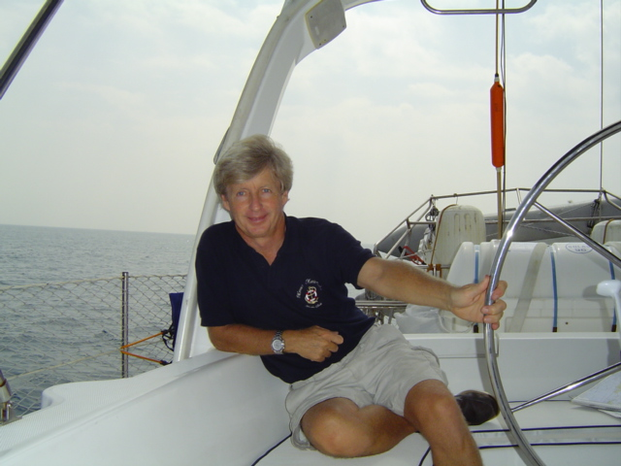CAPTAIN ANTHONY WALL

2711 Madison St.,

Hollywood, FL 33020

Tel 954 243 4078

e-mail; tonysailventures@gmail.com

website; sailventuresinc.com

blogsite; tonysails.com

An accomplished multi-talented individual with strong management,
communication and motivational skills.
Licensed, insured yachtbroker, Horizon Marine Center
Professional sailing instructor, American Sailing Association Instructor of the Year
Instructor Ratings to Advanced Coastal and Catamaran
A world-ranked captain/tactician with successes in Newport-Bermuda, Annapolis-Bermuda (winner) and The Havana Cup.
Advanced Level ASA Sailing Instructor; U.S. Instructor of the Year
50,000 blue water miles, including two Trans-Atlantic voyages, Trans-Pacific, Caribbean, Mediterranean, Aegean and Adriatic Seas
Published author-biographies and sailing related articles in the national press

My goals;
To continue working successfully with individuals looking to purchase sailing yachts, putting my worldwide racing and cruising experience to work in a high-integrity, stimulating environment

CAREER TRACK

President and Chief Operating Officer 1998-Present
Sailing Ventures International, Inc.

Biscayne Bay Sailing Academy
SVI; Lead instructor/captain responsible for devising and implementing sailing programs, marketing on-the-water teambuilding programs to Fortune 500 companies.
Frame and present the program to middle and top management, oversee on-water operations including lesson plan, provisioning and training of captains.
Yacht Delivery; more than 50,000 blue water miles – full references available. Yacht preparation, weather, planning, hiring, motivation and management of crew, mechanical repair and adjustments, storm survival, budgeting, provisioning and post-sail clean up and report to owners.
Biscayne Bay Sailing Academy; Start-up of company, registering with government and state agencies, development of website, hiring, motivation and training of instructors, marketing of company to national audience. Itinerary planning, provisioning, direct training of students establishing target goals, identifying strengths and weaknesses, safety procedures and examinations and certification by the American Sailing Association. Post-course follow-up including recommendations for selection of cruising grounds and assistance with yacht and charter company selection.
Horizon Marine Center Fort Lauderdale
Licensed, insured yacht-broker with excellent track record of completed transactions.

Executive Management 1993-1998
Nautica BC

A full service organization offering targeted member services, basic training and instruction, certifications, and specialized benefits to clients and members. Directed, from start-up, all aspects of daily operation. Negotiated equipment purchases and leases. Hired, developed and motivated staff. Devised and implemented all advertising and promotion. Communicated with licensing agencies and other governmental entities. Resolve customer service issues; administer banking and other financial issues including insurance, benefits, and all P&L factors. Expedite alliance / partnering arrangements enhancing organization’s perception as a national entity. Configure pricing.

• Provide critical leadership in all short- and long-range business and organizational planning leading to outstanding financial and operational results.

• Troubleshoot and resolve complex and / or sensitive issues; appropriate time and tasks to consistently meet deadlines and objectives.

• Dynamically promote organization through creative presentations, motivation of staff, and the development of targeted marketing approaches.

Page 2/3-Sailing Resume next

LEARNING CREDENTIALS

Bachelor of Arts - Economics
University of Birmingham, England

United States Coast Guard Master’s License
Certified Sailing Instructor

PERSONAL / INTERESTS

Willing to perform work related travel / Willing to relocate

CITIZENSHIP: U.S. and U.K.

SAILING RESUME

REFERENCES AVAILABLE UPON REQUEST

2000-2014 (all captain/master assignments)
- 54’ Jeanneau Grand Bahama-Dominican Republic
- 53” Jeanneau Miami-Key West-Miami
- 49’ Jeanneau Eastern Mediterranean and Tyrrenhean Sea. Italy, Corsica, sardinia
- 47’ Hanse Southern Turkey-Cyprus
- 40’ Pacific Seacraft Captain 6,500 milesFlorida-Bahamas, Bermuda, Azores, Gibraltar- Canary Islands-St Lucia. Published Blue Water Sailing Magazine July 2013
- 40’-46’ sailing catamarans Florida Keys and the Bahamas. Published Sail Magazine July 2012
- 40’ Keiser Sloop 900 miles Turkey-Cyprus
- 54’ Jeanneau Florida-Bahamas-Dominican republic
- 50’ Beneteau Managing Captain three months New England and Biscayne Bay and the Florida Keys
- 43’ Fountaine Pajot Annapolis-Miami
- 58’ Ketch Tortola BVI-Naples Fl
- 56’ Sunseeker Marine Instruction Florida Keys
- 51’ Beneteau Mediterranean Skipper August 2004
- 56’ Contessa Bahamas-Virgin Islands
- 45’ sailing catamaran Key West-Miami-Marsh Abaco Delivery,
- 40’ Pacific Seacraft Georgeous GirlCaptain/Tactician First in class, Annapolis-Bermuda
- 56’ Catamaran Skipper Palm Beach-Florida Keys
- 32’ Hunter, Grand Bahama-Miami. Delivery. Single-handed ocean passage, hand-steered
- 48’ Amel, Delivery Portland, Maine to Fort Lauderdale (1300 miles)
- 38’ Baltic Sapphire SeasTactician, First in class, Newport Bermuda Race
1999-2000
Multiple captained and instructional assignments out of Fort Lauderdale and Miami;
yachts 30-60 feet. Destinations: The Bahamas and the Florida Keys.

1993-1998
- 41’ Hans Christian, Captain First in class, Harvest Moon Regatta (Galveston-Port Aransas)
- 37’ Kirie, Tactician Fourth in class, Havana Cup (St. Petersburg-Havana)
- Beneteau 445, Captain British Virgin Islands
- J40, Captain Maine-Penobscot Bay
nautica fleet of 23-44’ sailing vessels, multiple captain/instructor assignments
Multiple charters in British Virgin Islands, Grenadines, eastern United States and Europe.
Beneteau 345, Captain US entry in the International Kornati Cup Dalmatian Coast of Yugoslavia
1992
Sailed Trans-Pacific: San Diego, Tahiti, Cook Islands, Tonga, New Zealand
1988
Crewed aboard winning boat in the Annapolis-Bermuda Ocean Race

QUALIFICATIONS
US Coast Guard Master’s License to 100 tons with towing and sailing endorsements.
American Sailing Association Advanced Instructor with ten degrees through Advanced Coastal Cruising
ASA Instructor of the Year.

ADDITIONAL INTERESTS
Teaching astronomy; international travel
French studies, language

EDUCATION
BA Economics Birmingham University, England

Page 3/3

